Question 1 – Wireshark

1.1

\* Filtered by “dhcpv6”

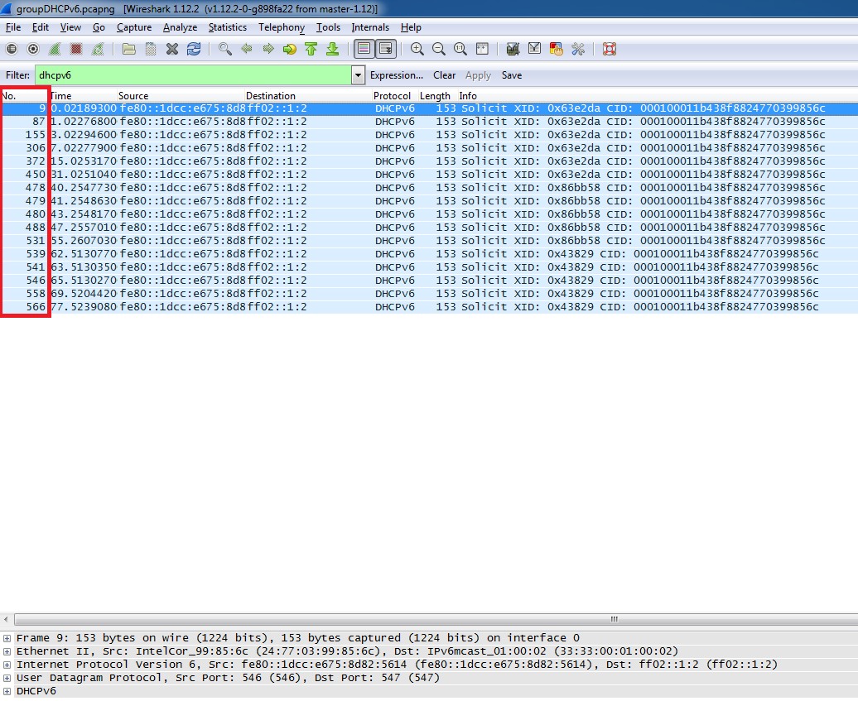

The purpose of the Solicit XID message is for a client to locate servers via a broadcast message. It is based on the DHCPv6 protocol and it’s DHCPv4 protocol equivalent would be a DHCP Discover message.

1.2 Selected frame #9

\* double clock on frame #9

